**Using web parts on SharePoint pages**

When you [add a modern page to a site](https://support.microsoft.com/en-us/office/create-and-use-modern-pages-on-a-sharepoint-site-b3d46deb-27a6-4b1e-87b8-df851e503dec#bkmk_addpage), you add and customize web parts, which are the building blocks of your page. You can add [text](https://support.microsoft.com/en-us/office/add-text-and-tables-to-your-page-with-the-text-web-part-729c0aa1-bc0d-41e3-9cde-c60533f2c801), [images](https://support.microsoft.com/en-us/office/use-the-image-gallery-web-part-bbcbe560-14a7-4369-8ef5-3255845e3bfd), [files](https://support.microsoft.com/en-us/office/use-the-file-viewer-web-part-e53a9602-e7b3-4fff-9126-de2f18d1900c), [video](https://support.microsoft.com/en-us/office/using-videos-on-sharepoint-pages-5a0eb37c-81a8-45b7-875e-ff0515dd2e5f), dynamic content, and more using the web parts listed in this article.

Add a web part

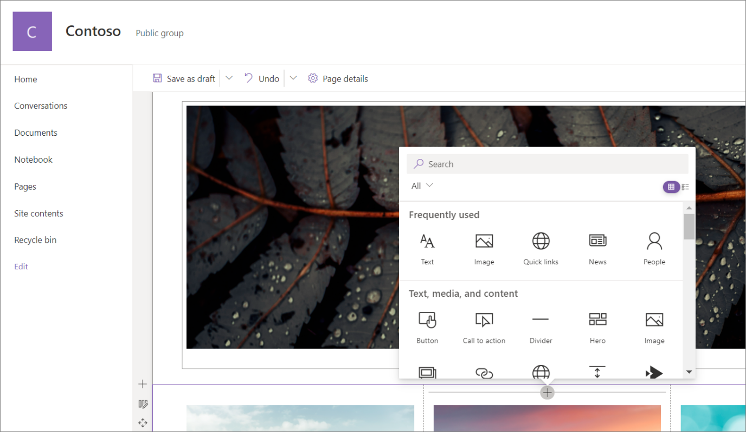

1. Go to the [page](https://support.microsoft.com/en-us/office/create-and-use-modern-pages-on-a-sharepoint-site-b3d46deb-27a6-4b1e-87b8-df851e503dec) where you want to add a web part.
2. If you do not see the site page that you want, click **Site contents** on the Quick Launch bar, in the list of contents, click **Site Pages**, and then click the page that you want.
3. If the page is not already in edit mode, click **Edit** at the top right of the page.
4. Hover your mouse above or below an existing web part and you'll see a line with a circled **+**, like this:

Plus sign for adding web parts to a page

1. Click **+** and you'll see a list of web parts to choose from. To easily find the web part you're looking for, start typing in the **Search** box.

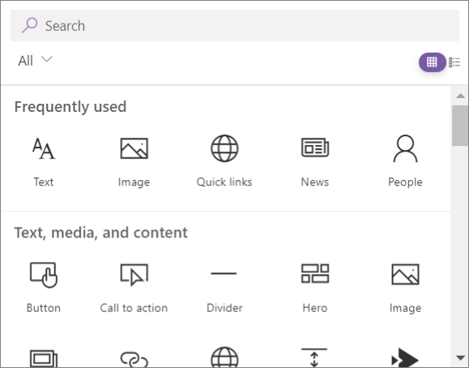

1. Click  alternate text  for a list view or  alternate text  for a grid view. You can also sort the web parts and filter them by category from the drop-down list.

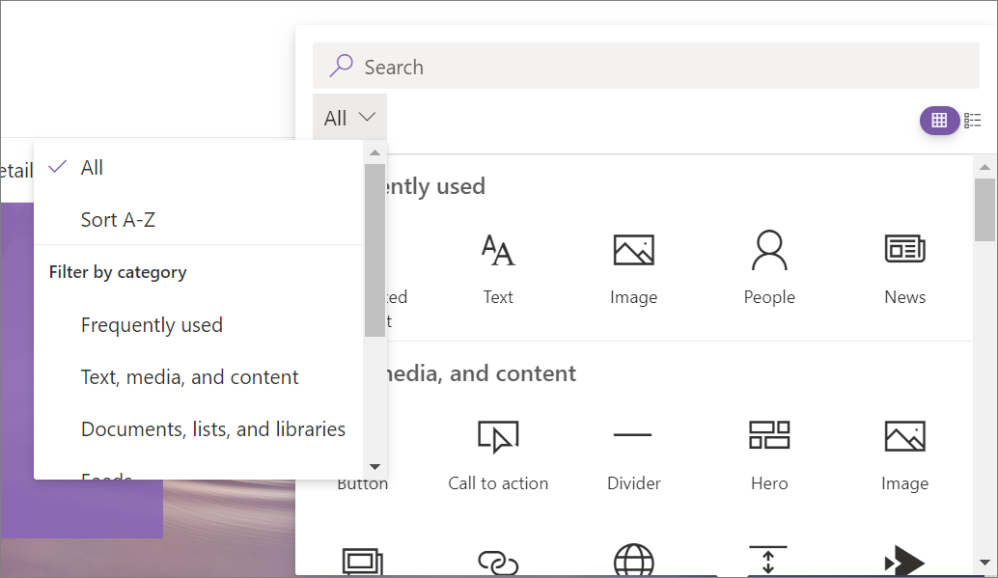

Move or remove a web part

1. If you're page is not already in edit mode, click **Edit** at the top right of the page.
2. Select the web part you want to move or remove, and you'll see a small toolbar on the left of the web part.

To move the web part, select the **Move web part** button Move web part button and drag the web part where you want it on your page.

To remove the web part, select the **Delete web part** button Delete web part icon . You can also select DEL on the keyboard to delete.

Available web parts

Following is a list of a web parts you can use on a page, along with links to more information for each web part.

1. Bing maps

The [Bing Maps web part](https://support.microsoft.com/en-us/office/use-the-bing-maps-web-part-c0e3f2f6-dc0d-49df-9308-1bf7c888e794) adds a map to your page. Simply enter an address or a well known name and your map will appear. You can choose a different map type, such as road or aerial. You can also change the zoom level or give your map pin a friendly name.

**Note: The Bing maps web part is not available in SharePoint Server 2019.**

1. Button

The [Button web part](https://support.microsoft.com/en-us/office/use-the-button-web-part-d2e37c48-11e8-45b9-8d9e-abdaa97c2a7a) easily adds a button to your page with your own label and link.

**Note:** The Button web part is not available in SharePoint Server 2019.

1. Call to Action

The [Call to Action web part](https://support.microsoft.com/en-us/office/use-the-call-to-action-web-part-e9917310-7543-4fc4-8f3f-d78e46074c00) creates a button with a call to action for users.

**Note: The Call to action web part is not available in SharePoint Server 2019.**

1. Code snippet

The [Code snippet web part](https://support.microsoft.com/en-us/office/use-the-code-snippet-web-part-d16d5aac-3e43-4d4d-aef3-d0ddbca64c05) easily displays code as text on your page for others to use or learn from. You can select the code language and a dark or light theme. The web part even auto-corrects syntax.

**Note: The Code snippet web part is not available in SharePoint Server 2019.**

1. Connectors

With the [Connectors web part](https://support.microsoft.com/en-us/office/use-the-connector-web-part-db0756aa-f78f-4b74-8b19-be5dca0420e1), you can get messages, alerts, and notifications from your favorite external services on a group-connected team site page. For example, you can show updates from services like Trello and Facebook; alerts when something new is published in an RSS feed; notifications from JIRA or GitHub; or even summaries from Salesforce and Google Analytics.

**Note: The Connectors web part is available only on group-connected team sites. It is not available on Communication sites or on any sites in SharePoint Server 2019.**

1. Countdown timer

The [Countdown timer web part](https://support.microsoft.com/en-us/office/use-the-countdown-timer-web-part-a13ffef8-0bf1-409e-be23-98af1d1736e7) displays a count down (or count up) to an event. You can add a title, set the date format, add a description, and a call to action button with a link.

**Note: The Countdown timer web part is not available in SharePoint Server 2019.**

1. Divider

The [Divider web part](https://support.microsoft.com/en-us/office/add-a-line-between-web-parts-with-the-divider-web-part-7204a0fa-f0c2-4f1e-8e7b-d0ebd4276ad4) inserts a line between other web parts to help break up your page and make it easier to read.

1. Document library

The [Document Library web part](https://support.microsoft.com/en-us/office/use-the-document-library-web-part-a9dfecc3-2050-4528-9f00-2c5afc5731b0) displays a document library and customize it with your own title, view, and even size. Users with appropriate permissions can view or edit files directly from the web part, or can go to the full document library by clicking **See all**.

1. Embed

The [Embed web part](https://support.microsoft.com/en-us/office/add-content-to-your-page-using-the-embed-web-part-721f3b2f-437f-45ef-ac4e-df29dba74de8) displays content on your page from other sites like YouTube videos. Depending on the site, you can either use the site's address or embed code that the site provides.

1. Events

The [Events web part](https://support.microsoft.com/en-us/office/use-the-events-web-part-5fe4da93-5fa9-4695-b1ee-b0ae4c981909) allows you to add and display upcoming events on your page. You can even include a map with location, online meeting information, and more.

1. File viewer

The [File viewer web part](https://support.microsoft.com/en-us/office/use-the-file-viewer-web-part-e53a9602-e7b3-4fff-9126-de2f18d1900c) insert a files on your page. File types you can insert include Excel, Word, PowerPoint, Visio, .PDFs, 3D Models, videos, and more.

**Note: Note: In SharePoint 2019, file types that can be inserted are limited to Word, Excel, and PowerPoint (specifically .doc, .docx,. xls, .xlsx, .pot, .potx, .ppt and .pptx).**

1. Group calendar

The [Group calendar web part](https://support.microsoft.com/en-us/office/use-the-group-calendar-web-part-eaf3c04d-5699-48cb-8b5e-3caa887d51ce) puts a [group calendar](https://support.microsoft.com/en-us/office/schedule-a-meeting-on-a-group-calendar-in-outlook-0cf1ad68-1034-4306-b367-d75e9818376a) right on your page so that it is easily visible to your readers.

**Note: The Group calendar web part is not available in SharePoint Server 2019.**

1. Hero

The [Hero web part](https://support.microsoft.com/en-us/office/use-the-hero-web-part-d57f449b-19a0-4b0d-8ce3-be5866430645) is a great way to bring focus and visual interest to your page. You can display up to five items in the Hero web part and use compelling images, text, and links to draw attention to each. The Hero web part is included by default on Communication sites, but you can also add the Hero web part to other pages.

1. Highlighted content

The [Highlighted content web part](https://support.microsoft.com/en-us/office/use-the-highlighted-content-web-part-e34199b0-ff1a-47fb-8f4d-dbcaed329efd) dynamically displays content based on content type (documents, pages, news, videos, images, etc), filtering, or a search string. You can also set the scope of the search to a site or site collection, and sort the results.

1. Image

The [Image web part on a page](https://support.microsoft.com/en-us/office/use-the-image-web-part-a63b335b-ad0a-4954-a65d-33c6af68beb2) inserts an image on the page, either from your site, your OneDrive, or your hard drive.

1. Image gallery

The [Image Gallery web part](https://support.microsoft.com/en-us/office/use-the-image-gallery-web-part-bbcbe560-14a7-4369-8ef5-3255845e3bfd) shares collections of pictures on a page. Simply select your images with the file picker or drag them onto the web part. Once you’ve created your collection, you can drag and drop the images to reorder them as needed.

1. Kindle Instant Preview

Have a book you want to recommend or promote on your page? The [Kindle Instant Preview web part](https://support.microsoft.com/en-us/office/use-the-kindle-instant-preview-web-part-efc126dd-1916-432a-8de6-08f1a5b822b3) shares a preview of a Kindle book.

**Note: The Kindle Instant Preview web part is not available in SharePoint Server 2019.**

1. Link

The [Link web part](https://support.microsoft.com/en-us/office/use-the-link-web-part-19c37587-118a-4813-b25a-192f3bd829d9) adds a link to an internal or external page, video, image, or document.

**Note: The Link web part is not available in SharePoint Server 2019.**

1. List

The [List web part](https://support.microsoft.com/en-us/office/use-the-list-web-part-ef0a1b80-f8b3-443d-b04a-1e76c70b5537) displays a list that you can customize with your own title, view, and even size. Users can view the list, or go to the full list by clicking **See all**.

1. List properties

The [List properties web part](https://support.microsoft.com/en-us/office/use-the-list-properties-web-part-f7227df0-fbfb-4d75-84cb-d45fcd811af2) connects to a list web part on the same page and display items from the list based on what a user selects.

**Note: The List properties web part is not available in SharePoint Server 2019.**

1. Markdown

The [Markdown web part](https://support.microsoft.com/en-us/office/use-the-markdown-web-part-6d73c06d-2877-4bc9-988b-f2896016c50b) adds text to your page and format it using Markdown language.

**Note: The Markdown web part is not available in SharePoint Server 2019.**

1. Microsoft Forms

The [Microsoft Forms web part](https://support.microsoft.com/en-us/office/use-the-microsoft-forms-web-part-d4b4d3ce-7860-41e4-8a98-76380efe7256) can create surveys, quizzes, and polls on a page. You can also collect responses to your forms and show form results.

**Note: The Microsoft Forms web part is not available in SharePoint Server 2019.**

1. My feed

The [My feed web part](https://support.microsoft.com/en-us/office/use-the-my-feed-web-part-d5c79a85-0596-4602-975a-9c06824b09c7) shows a mix of content from across Microsoft 365, based on what's likely to be most relevant to the current user at any given time.

1. News

The [News web part](https://support.microsoft.com/en-us/office/use-the-news-web-part-on-a-sharepoint-page-c2dcee50-f5d7-434b-8cb9-a7feefd9f165) keeps your team in the loop as well as engages them with important or interesting stories. You can quickly create eye-catching posts like announcements, people news, status updates, and more that can include graphics and rich formatting.

1. Organization chart

Use this web part to show a visual [organization chart](https://support.microsoft.com/en-us/office/use-the-organization-chart-web-part-77e3fd2e-568c-454c-a0b4-611eb79fce11) by choosing a person to build the chart around. You can specify how many reporting levels up you want to show.

1. Page properties

The [Page properties web part](https://support.microsoft.com/en-us/office/use-the-page-properties-web-part-1a99cb9c-a5f1-441b-8e5d-643b0f0ff736) provides details about your page, such as title, date, content type, and more.

**Note: The Page properties web part is not available in SharePoint Server 2019.**

1. People

The [People web part](https://support.microsoft.com/en-us/office/show-people-profiles-on-your-page-with-the-people-web-part-7e52c5f6-2d72-48fa-a9d3-d2750765fa05) displays a selected group of people and their profiles on your page. It can be used for contact information, team information, presenters, and more.

1. Planner

The [Planner web part](https://support.microsoft.com/en-us/office/use-the-planner-web-part-a1e4ada8-8817-4e57-8e65-1bf546808843) adds your team's tasks and assignments on a page using Microsoft Planner.

**Note: The Planner web part is available only on group-connected team sites. It is not available on Communication sites or on any sites in SharePoint Server 2019.**

1. PowerApps

PowerApps is a service that lets you build business apps that run in a browser or on a phone or tablet, with no coding experience required. Once you have created or customized an app using the service, you can add it to your SharePoint page with the [PowerApps web part](https://support.microsoft.com/en-us/office/use-the-power-apps-web-part-6285f05e-e441-408a-99d7-aa688195cd1c). Just enter the app’s web address or the app ID, and then resize the app to fit the page.

**Note: The PowerApps web part is not available in SharePoint Server 2019.**

1. Power BI report

The [Power BI web part](https://support.microsoft.com/en-us/office/use-the-power-bi-web-part-32d8b85f-094d-4152-8e3b-df641ccf3968) easily embeds an interactive Power BI report on your page. The embedded reports are fully secure so you can easily create secure internal portals.

**Note: The Power BI web part is not available in SharePoint Server 2019.**

1. Quick chart

The [Quick Chart web part](https://support.microsoft.com/en-us/office/use-the-quick-chart-web-part-bcfee244-2408-400b-a9bd-4eca61aead51) adds simple charts to your page. Enter your data points, add labels, pick your chart type -- column or pie -- and publish.

1. Quick links

The [Quick Links web part](https://support.microsoft.com/en-us/office/use-the-quick-links-web-part-e1df7561-209d-4362-96d4-469f85ab2a82) "pins" items to your page for easy access.

1. Recent documents

The [Recent documents web part](https://support.microsoft.com/en-us/office/use-the-recent-documents-web-part-8aa8c0f2-d2e3-43f9-90f5-fd6ddf0669c3) displays documents that have been recently added or edited.

**Note: The Recent documents web part is not available in SharePoint Server 2019.**

1. Saved for later

Users can "save" pages, news posts, and documents to view later in SharePoint. They can then easily view what they saved with the [Saved for later](https://support.microsoft.com/en-us/office/use-the-saved-for-later-web-part-7bf0682f-a273-4d81-9424-0d90972f8750) web part.

**Important:** Only pages and news posts can be saved for later in the browser. In the SharePoint mobile app, you can also save documents for later.

1. Site activity

The [Site Activity web part](https://support.microsoft.com/en-us/office/use-the-site-activity-web-part-1fa91401-ac36-42b6-beba-bb8469d6cbfa) automatically shows recent activity on your site, such as files uploaded, edits made, lists and libraries created, and so on. Just add the web part, and the latest activity is pulled in automatically.

1. Sites

The [Sites web part](https://support.microsoft.com/en-us/office/use-the-sites-web-part-93cbd17b-0bf8-4355-9f32-cc90e0443e6d) showcases sites on a page. You can select specific sites to show, or have sites show dynamically based on a hub site association or on a user's frequently used sites.

**Note: The Sites web part is not available in SharePoint Server 2019.**

1. Spacer

The [Spacer web part](https://support.microsoft.com/en-us/office/add-vertical-space-to-a-page-with-the-spacer-web-part-7e6ae288-1634-44e2-bc4c-7fb4042ee905) allows you to control vertical space on your page.

1. Stream (classic)

The [Stream (classic) web part](https://support.microsoft.com/en-us/office/use-the-stream-classic-web-part-b97fa87c-1337-4271-a059-17f0d2b26e8b) displays a video right on your page from your organization's Microsoft Stream (classic) video portal.

1. Text

The [Text web part](https://support.microsoft.com/en-us/office/add-text-and-tables-to-your-page-with-the-text-web-part-729c0aa1-bc0d-41e3-9cde-c60533f2c801) adds paragraphs and tables to your page. Formatting options like styles, bullets, indentations, highlighting, and links are available.

1. Twitter

The [Twitter web part](https://support.microsoft.com/en-us/office/use-the-twitter-web-part-15db6b3b-d167-41dd-9875-2af64b44d820) shows tweets that are relevant to you or your audience right on your page.

**Note: The Twitter web part is not available in SharePoint Server 2019.**

1. Weather

The [Weather web part](https://support.microsoft.com/en-us/office/show-the-weather-on-your-page-4a86540e-0846-4fc0-bad0-1a82fcd430fc) shows the current weather on your page.

**Note: The Weather web part is not available in SharePoint Server 2019.**

1. World clock

The [World clock web part](https://support.microsoft.com/en-us/office/use-the-world-clock-web-part-aa2ede87-e331-44f1-a116-a5b8fc67fd04) shows the time in different locations around the world.

**Note: The World clock web part is not available in SharePoint Server 2019.**

1. Yammer

The [Yammer web part](https://support.microsoft.com/en-us/office/use-a-yammer-web-part-in-sharepoint-online-a53cfa0c-3d09-42c8-a286-1038a81c59da) enhances collaboration by embedding Yammer conversations on your page, if your organization has an active Yammer network (for example: www.yammer.com/contoso.com).

1. YouTube

The [YouTube web part](https://support.microsoft.com/en-us/office/use-the-youtube-web-part-c14fa2c1-71dc-4e52-94b6-b4876742382f) easily embeds YouTube videos right on your page.

**Note: The YouTube web part is not available in SharePoint Server 2019**

* Web parts you can connect

You can connect some web parts to each other to create an interactive and dynamic experience for your page viewers. For example, you can connect a Document library web part to a File viewer web part. When a user clicks a file name in the Document library list, the File viewer shows the contents of that specific file. Or, connect a List web part or Document library web part to an Embed web part, and add custom code for a variety of dynamic experiences.

Web parts you can connect include: the List properties web part, File viewer web part, and Embed web part.

For information and examples, see [Connect web parts in SharePoint](https://support.microsoft.com/en-us/office/connect-web-parts-in-sharepoint-b457668c-d843-4b1b-8977-a6f9228a1dec).

* Web part maintenance mode

Having trouble with web parts you've put on a page? Try using [using web part maintenance mode](https://support.microsoft.com/en-us/office/eff9ce22-d04a-44dd-ae83-ac29a5e396c2) to help troubleshoot the issue.